COOP weed analysis log

Ideas:
NMDS on phylogenetic distance or with CC biomass as an explanatory variable?
Perhaps an RDA or CCA on some beta-diversity metric?

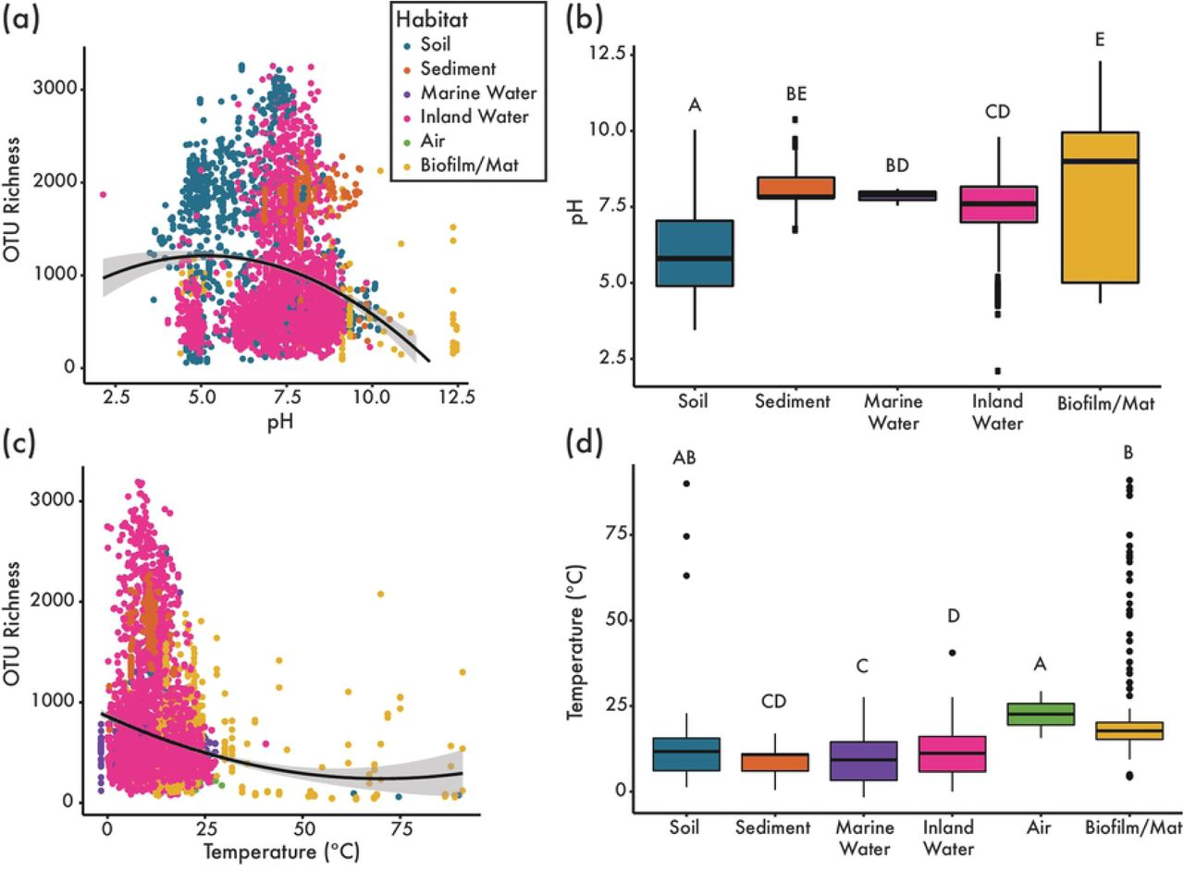

Phylogenetics

Data preparation and manipulation
- Unknown species (n = 5) are removed from phylogenetic analysis

Tree building
- The tree was made with V.PhyloMaker2::phylo.maker using scenario3 and build.nodes.1
  - Build.nodes.1: Returns the most recent common ancestor (MRCA) of all the tips in the largest cluster of the genus and defines it as the basal node of the genus. I feel like this is better because it’s less prone to an outlier.
  - Scenario 3: New genus: the new tip is bound halfway between the family branch and basal node or in the “upper” 1/3 of the branch if the “family branch” length is really long. New species: Bound to the basal node of the genus. I think this is better than the other two scenarios, see “notes” in reading.
- All families were listed in the mega-tree, but there were 9 species that were not in the existing data. I used published phylogenies to list related species or genera.
- The bound tree showed a more accurate fit as the unknown species were not bound at the family node. I feel good about the binding.

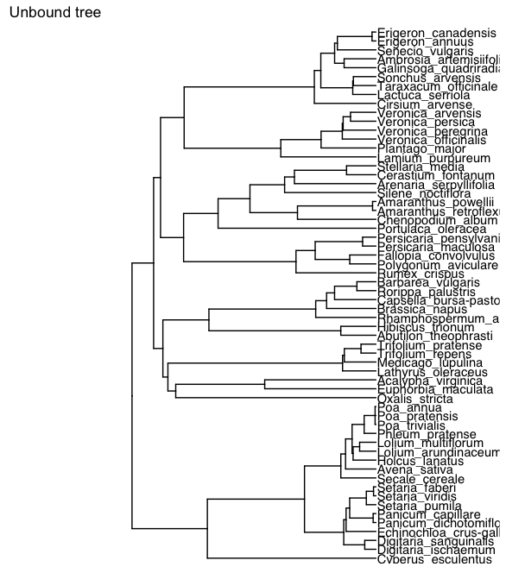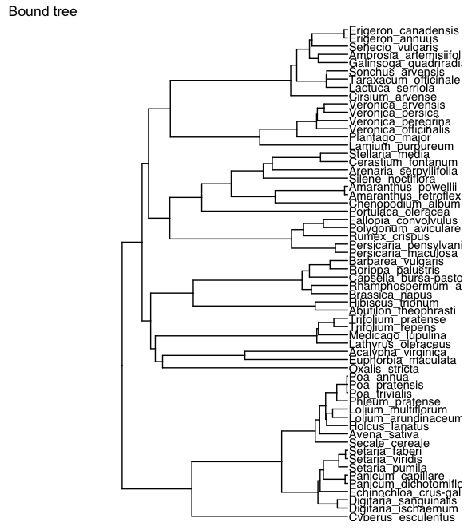

However, there were three Poa species that were only bound to the relative genera, this caused the resulting tree to have a polytomy across these three Poa species. Many null models assume ultrametric trees, so to deal with the polytomy, I randomly resolved it using the multi2d()function.

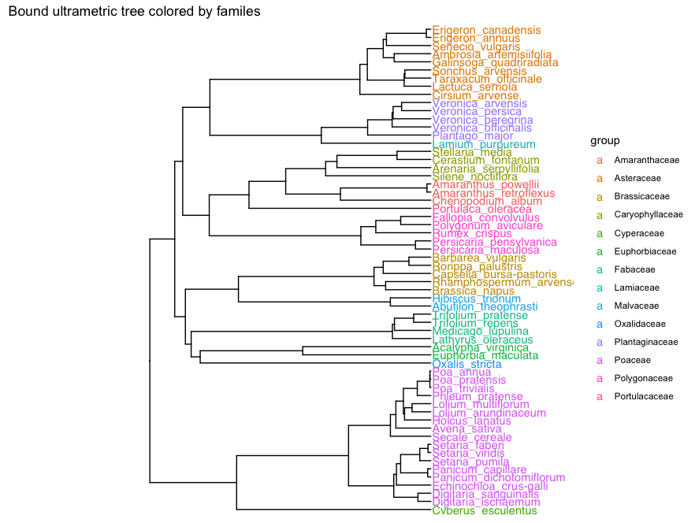

Analysis prep
- Confirmed that community abundance data and phylogenetic trees had matching names
- Created data frames of the matched names and removed missing sample – “COOP2_Farm Hub_2021_3_14_Tilled”, which was nessary for analysis
- Created a Phylogenetic resemblance matrix

a phylogenetic resemblance matrix, or a phylogenetic variance-covariance matrix, is nothing more than the calculated distances between taxa in a tree. It is necessary for all estimation of the phylogenetic structure.
In R, we commonly refer to this matrix as a matrix of cophenetic distances among taxa and we can use the cophenetic() to calculate it.

Analysis
- Calculated interspecific MPD
  - Interspecific MPD was used because, compared to other metrics of phylogenetic distance, it has low error and it is not affected by species richness (), which allows it to be used as a response variable across treatments ().
  - Inter.MPD quantifies mean relatedness among species
- Confirmed that the regional tree does not affect interspecific MPD
- Modeling (Confirm/add model testing)
  - The analysis will be split by experiment to compare cover crops to their respective control aka “resident” weed community diversity
  - The tilled control has no cover crop biomass, so CoverCrop*Biomass gives singularity with all the data I will have to do two sets of models:
    - Weed suppression: Two models because of co-linearity
      - WeedBiomass ~ Site*CoverCrop
      - WeedBiomass ~ Site*CoverCropBiomass
    - Cover crop comparisons: inter.mpd ~ Site*CoverCrop, with all data
    - Biomass effect: inter.mpd ~ Site*CoverCrop*Biomass, no control
    - Directionality: inter.mpd ~ Site*CoverCrop*CCpresence
  - Random effects were always (1|SiteYear/Block) to account for spatial-temporal variation between replicates and variation within a field.
  - All glmer models were assessed with car::Anova(type=3) test. lmer tests had to be assessed with anova() due to a nonsensical result for summer biomass. This is not a problem because both methods are type three ANOVA tests.
  - The fit of linear mixed effect models was confirmed by assessing residuals. Similarly, generalized linear mixed effect model fit was confirmed with simulated residuals.
- Visualizing
  - Treatment effects and Suppression: Bars are arithmetic means and error bars show standard error. The letters above the bars denote treatments effects (alpha = 0.95) and were calculated with FisherLSD tests of the model’s estimated marginal means.
  - Biomass: Points show interspecific MPD, and lines show regression model output.
  - Direction: Points show interspecific MPD and cover crop effects on weed community phylogenetic distance are denoted by 95% confidence intervals.
  - Heatmap
    - Clusters treatments by average inter.MPD and connects them to a dendrogram of phylogenetic spread using average weed biomass
      - The average inter.MPD of each treatment was converted to a Euclidian distance matrix with dist(). The distance matrix was then grouped with complete linkage hierarchical clustering using hclust().
      - Note that rownames need to be in the same order for the heatmap to work (I spent a long time trying to figure this one out).

List of final models
- Weed suppression (Treatments) – All treatments
  - Winter
glmmTMB(WeedBiomass ~ Site*CoverCrop + (1|SiteYear/Block),
family = tweedie(),data = SupressionDataWint)
  - Summer
glmmTMB(WeedBiomass ~ Site*CoverCrop + (1|SiteYear/Block),
family = tweedie(),data = SupressionDataSum)
- Weed suppression (regression)
  - Winter
glmmTMB(WeedBiomass ~ Site*CoverCropBiomass+(1|SiteYear/Block), family = tweedie(), data = SupressionDataWint_CC)
  - Summer
glmmTMB(WeedBiomass ~ Site*CoverCropBiomass + (1|SiteYear/Block), family = tweedie(), data = SupressionDataSum_CC)
- Treatment comparison – all treatments, just weed data
  - Winter
glmmTMB(inter.mpd ~ Site*CoverCrop+(1|SiteYear/Block),
family = gaussian(link = “log”),
data = AlphaAnalysisWint)
  - Summer
glmmTMB(inter.mpd ~ Site*CoverCrop+(1|SiteYear/Block),
family = gaussian(link = “log”),
data = AlphaAnalysisSum)

- Biomass vs. species effect – just cover cropped treatments, just weed data
  - Winter
lmer(inter.mpd ~ Site*CoverCropBiomass*CoverCrop +
(1|SiteYear/Block), data=AlphaAnalysisWint_CC)
  - Summer
lmer(inter.mpd ~ Site*CoverCropBiomass*CoverCrop +
(1|SiteYear/Block), data=AlphaAnalysisSum_CC)
- Directionality - just cover cropped treatments, just all data
  - Winter
lmer(inter.mpd ~ Site*CoverCrop*CC.Pres + (1|SiteYear/Block),
data=CC_DirrectionDataWint)
  - Summer
lmer(inter.mpd ~ Site*CoverCrop*CC.Pres + (1|SiteYear/Block),
data=CC_DirrectionDataSum)

